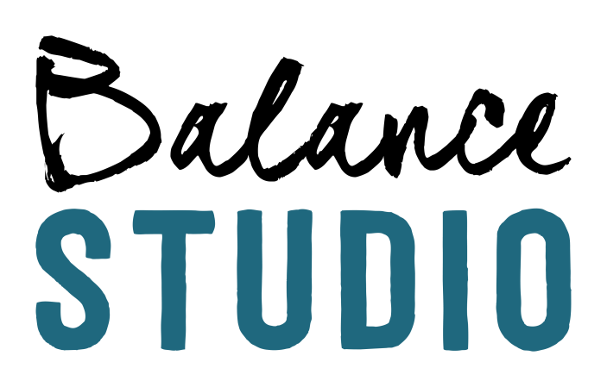
Competitive Cheer Competition Schedule
November 20th- Crown Cup Champions : Harrisburg SD
December ???- Holidazzle- Brandon SD
January 15th- Best of the Midwest- Fargo ND
January 22nd & 23rd- American Heartland Council- Bluffs IA
January 30th -Valentines Classic Competition: Sioux Falls SD
February 20st- Baby I’m a Star: Mitchell SD- Corn Palace
March 12th & 13th - Baby I’m a Star: Sioux Falls SD
March 26th - Rumble in the Jungle: Brookings SD- Swiftel Center
April 10th The Final Bash : Des Moines IA
April 30th - Balance Studio Spring Showcase- OCC

